📘 **SQL Project Report: Data Manipulation**

**Objective**

Enhance skills in SQL by modifying table structures and managing records through adding columns and deleting specific records based on conditions.

**Database Setup**

**Query:**

CREATE DATABASE CompanyDB;

USE CompanyDB;

**Query Explanation:**

Creates a new database named CompanyDB.

Switches context to use this database.

**Table Creation:**

**Query :**

CREATE TABLE Employees ( EmpID INT PRIMARY KEY,Name VARCHAR(50),Department VARCHAR(50),

JoiningDate DATE);

DESC Employees;

**Query Explanation:**

Creates an Employees table with basic employee information.

**Output:**

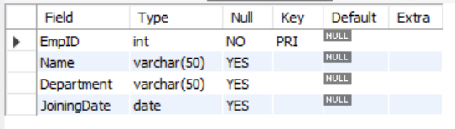

**Output Explanation:**

Table with four columns is successfully created.

**Insert Sample Data:**

INSERT INTO Employees (EmpID, Name, Department, JoiningDate) VALUES

(1, 'Aarav', 'HR', '2022-05-10'),(2, 'Bhavya', 'Finance', '2021-12-15'),(3, 'Charan', 'IT', '2023-03-20'), (4, 'Divya', 'HR', '2022-01-10'),(5, 'Esha', 'Marketing', '2020-08-25');

SELECT * FROM Employees;

**Query Explanation:**

Inserts five sample employee records using common Indian names.

**Output:**

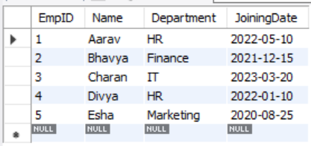

**Output Explanation:**

**Datas are inserted in the table**

**Step 1: Modify Table Structure**

**Add New Columns**

ALTER TABLE Employees ADD COLUMN LastUpdated DATE;

ALTER TABLE Employees ADD COLUMN Status VARCHAR(10) DEFAULT 'Active';

DESC Employees;

**Query Explanation:**

Adds LastUpdated (DATE) and Status (VARCHAR) columns.

**Output:**

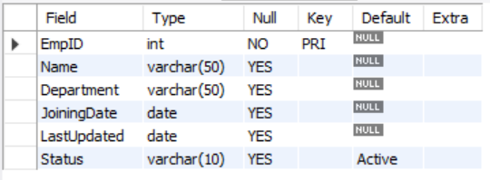

**Output Explanation:**

Table structure now includes two additional columns.

**Populate New Columns**

UPDATE Employees SET LastUpdated = CURRENT_DATE WHERE Status = 'Active' AND EmpID=3;

SELECT * FROM Employees;

**Query Explanation:**

Updates all records with today’s date and sets their status as 'Active'.

**Output:**

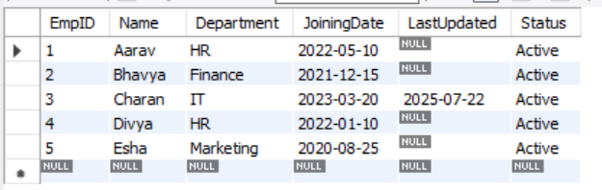

**Output Explanation:**

All records now have values for LastUpdated and Status.

**Step 2: Delete Records Based on Conditions**

**Delete Inactive Records**

-- Mark Bhavya and Esha as inactive

UPDATE Employees SET Status = 'Inactive' WHERE EmpID IN (2, 5);

-- Delete inactive records

DELETE FROM Employees WHERE EmpID IN (101, 102) AND Status = 'Inactive';

SELECT * FROM Employees WHERE Status = 'Inactive';

**Query Explanation:**

First marks two employees as Inactive.Then deletes them from the table.

**Output:**

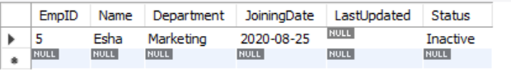

**Output Explanation:**

Bhavya and Esha are removed from the table.

**Delete Records Older Than Specific Date**

DELETE FROM Employees WHERE LastUpdated < '2023-01-01';

SELECT * FROM Employees;

**Query Explanation:**

Deletes employees whose records haven’t been updated since before Jan 1, 2023.

**Output:**

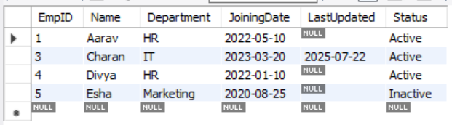

**Output Explanation:**

Removes outdated records such as Aarav or Divya if applicable.

**📊 Summary of Findings**

Total initial records: 5

Inactive records deleted: 2 (Bhavya and Esha)

Old records deleted: Based on LastUpdated condition

Final records: Remaining employees like Charan or Divya